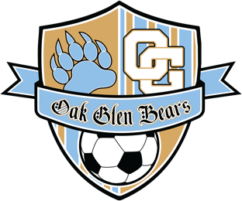 | OAK GLEN HIGH SCHOOL |  | DICK SHILLING  ATHLETIC DIRECTOR
 | Athletic Department  195 Golden Bear Drive  New Cumberland, WV 26047 | Telephone (304) 387-2063 x3752  (304) 564-3500 x6  Fax (304) 387-2079  Email: richard.shilling@k12.wv.us
 | Home of the Golden Bears

2023 Oak Glen Girls Soccer Schedule

Day Date Opponent Location Time Bus

Sat 6/18 Fairmount 7v7 East-West Stadium – Fairmont 8am 5am
Sat 8/12 Brooke Soccer Rama Brooke High School 12pm 11:15am
Mon 8/14 Steubenville Central Oak Glen Multi Sports Complex 6pm
Wed 8/16 Cambridge Oak Glen Multi Sports Complex 5pm
Thur 8/17 East Liverpool East Liverpool High School 6am 4:30am
S\at 8/19 Fairmont Senior East/West Stadium in Fairmont 11am 7:45am
Tue 8/22 Steubenville Oak Glen Multi Sports Complex 6pm
Sat 8/26 Morgantown Oak Glen Multi Sports Complex 11am
Mon 8/28 Beaver Local Beaver Local High School 7pm 5:15pm
Thur 8/31 Weir Oak Glen Multi Sports Complex 6pm
Sat 9/2 North Marion Oak Glen Multi Sports Complex 11am
Tue 9/5 Brooke Oak Glen Multi Sports Complex 6pm
Sat 9/9 Philip Barbour Philip Barbour High School 12pm 8am
Tue 9/12 Linsly Oak Glen Multi Sports Complex 6pm
Sat 9/16 University University High School 11am 8am
Tue 9/19 Madonna Oak Glen Multi Sports Complex 6pm
Sat 9/23 Lincoln High School Lincoln HS – Shinnston, WV 1pm 9:30am
OVAC Tournament September 26 – October 1
Tue 10/4 Wheeling CC Oak Glen Multi Sports Complex 6pm
Wed 10/5 John Marshall John Marshal High School 6:00pm 3:30pm
Tue 10/10 St. Clairsville Oak Glen Multi Sports Complex 6pm
Thur 10/12 Indian Creek Oak Glen Multi Sports Complex 6pm
Sectional Tournament - Oct 16-21, 2023
Regional Final - Oct 24-26, 2023
State Tournament - Nov 3-4, 2023

Head Coach: Bill Watts; Assistant Coach: Jaison Polly

